SOFTWARE REQUIREMENT SPECIFICATION

ONLINE SHOPPING SYSTEM

- Monibala S

ABSTARCT:

The online shopping system is a diverse E-platform where the customers can view and buy the products at their door steps.It helps the shop owners to create virtual shops to enhance their sales and makes it easy and user friendly to access the items.This system will provide efficient interface and wide range of products to the customers.

The software requirement specification document for the online shopping system outlines the features and the key component with needed specification and requirements as a guide for the Developers to create a portable and enhanced online shopping mart.it makes easier for the developers to understand all the requirements and easily understandable by the end users.

REQUIREMENTS:

Functional requirements:

Functional Requirements defines the key components and the functions that the system requires to perform.These Functional Requirements are demanded from the end user and must incorporated specifically to achieve customer satisfactions.

The Functional Requirement for the online shopping System

Registration:

If a Customer uses the System for the first time he/she must register with username and password and get authorized to proceed with the shopping

Login page :

The Registered User can login to the System with their username and password and get authenticated for further shopping and to avail the features.

Home page:

The Home page displays the most viewed items and the suggestions for the customers as a overview of the System.

Categories:

To make the customer feel comfortable and easier to access the the items,the category page avails the segregation filters so that its easier to access the system.

Wish-list:

The wish-list page has the liked items by the customers where they could buy it later to make it convenient to access whenever necessary.

Add to cart:

The cart displays the item that were selected by the customers to buy.

Payment :

The payment page contains the payment options and the total cost of the product.

Orders:

The Order page contains the items that were ordered by the customers and the status of the shipping.

Non -Functional requirements

The Non-Functional requirements defines the quality of the system.They are defined by the Technical people.It’s helpful in analysing the overall performance of the system.

Availability:

The website can be accessed 24/7 by the customer.

Scalability:

Since it’s a online platform it can be accessed from anywhere in the world by the customer

User-friendly:

It’s a user friendly app that provides support for the customers and can be easily accessed.

Security:

It is a secured app that makes the payment transaction and the customer details most confidential.

High performance:

The performance of the app is very fast and it response time is higher.

Usability:

The user Interface is simple and convenient that it can be embedded in any device and can be used by everyone.

DESCRIPTION:

The Login page has the Registration option for the new user and the Sign up option for the Registered user.The User must sign in with their user name and password.

After signing the User can view the most viewed products and the recently viewed items in the Homepage and the discounts and deals that are available.

The User can use the category page to search the product and add them to the wish-list or cart

The items can be directly added to the cart or the from the wish-list to know about the total items and the total cost of the products.

Once the Item are added to the cart If he/she willing to buy they could buy them using order now option

Then the total cost and the payment options are displayed to the customer they could choose the and confirm payment.

After successful payment the shipping details are mailed to the customer and the tracking of the shipping is visible in the system.

The customers could track the delivery and after delivery they could send their feedback for the improvement of the system.

FLOW CHART DIAGRAM:

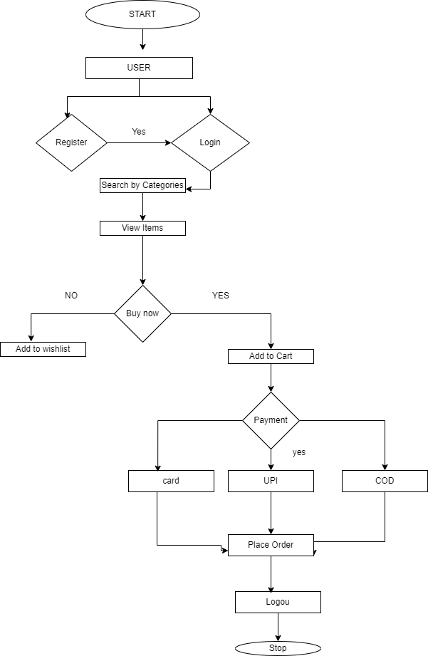

USE CASE DIAGRAM:

The Use-Case Diagram is a behavioural diagram which defines the interaction between the System and the End User.It describes the Function of the System.

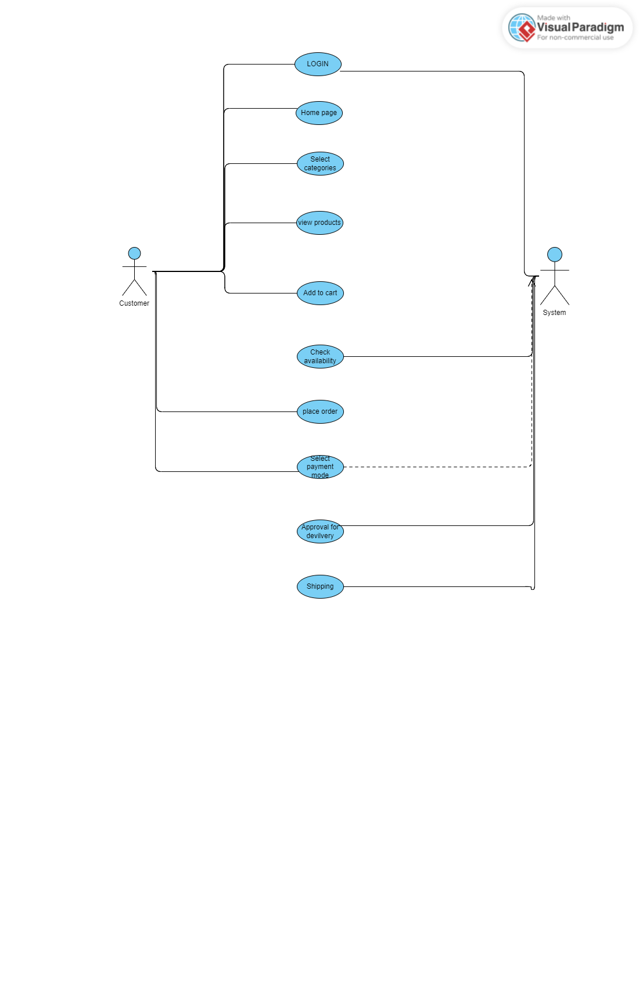

CLASS DIAGRAM:

Class Diagram is a Structural UML Diagram.It is used to represent the structure and the Relationship of Classes.

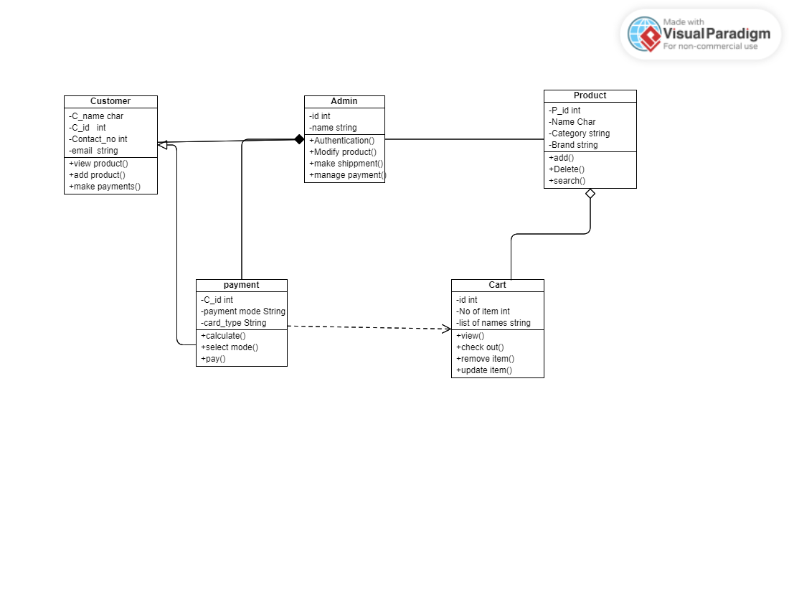

SEQUENCE DIAGRAM:

Sequence Diagram is a interaction Diagram that represents the flow of events that Take place one after another.It is also known as Event driven Diagram.

